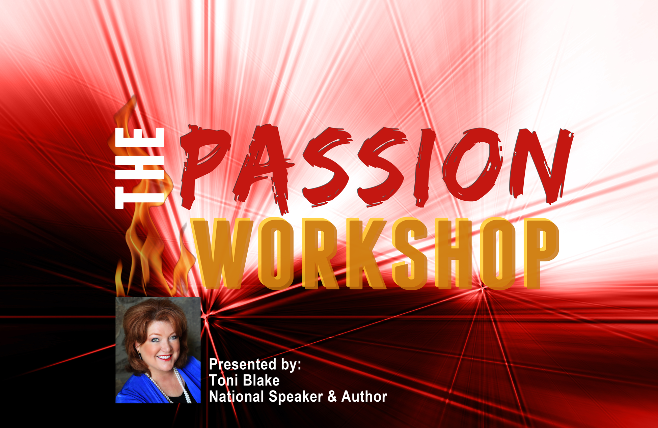
The Passion Workshop
Presented by Toni Blake

90 Minute Keynote

Appropriate for ALL STAFF

Empowerment:
You’ve Got the Power!
• You decide!
• Adjust your perceptions – adjust your results
• Clarify your vision – produce the pathway to winning

Re-Imagine Yourself:
Unleash Your Highest Standard of Passion
• The psychology
• The science
• The time-tested techniques

Defined Characteristics of the Heart:
Interactive Session: Personal Exercises
• Take the positive energy test
• Review your personal talent inventory: understand your gifts
• Affirm your self-esteem, excuses versus success
• Align your passion with purpose
• Test your courage
• Decide on your “I AM” character lessons

Group Mastermind Session:
• Role-play with discussion – impact of negative/ positive words
• Team activities – review best practices by position, score your team
• Personality test – self-evaluation/ working with each personality
• Balance the influence of others both positive & negative
• Recognize transformation moments when you can turn negative
experiences into positive fuel for your greatest triumphs

Take a personal development journey with your team on a step-by-step
roadmap as you master the highest level of excellence. This 90-minute
keynote is for your entire team. Note: This session is brand new! I will
be promoting it for the first time with my 2016 seminars and would love
to present it at your next management meeting.

