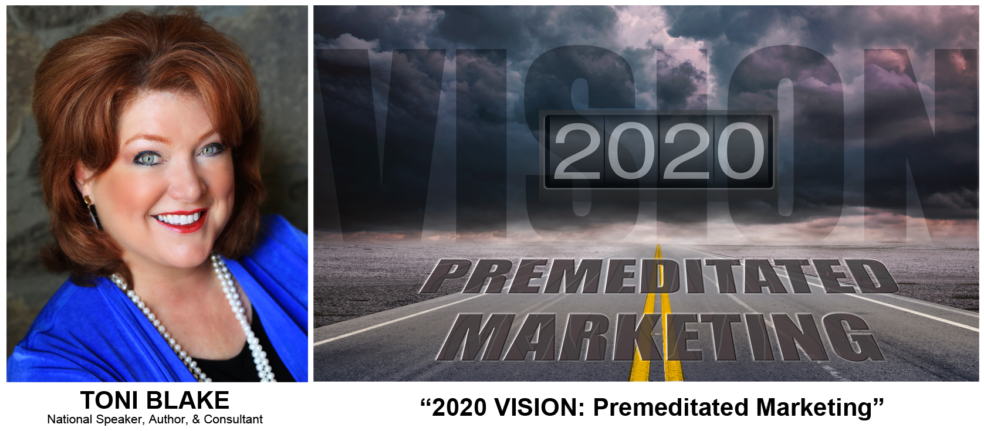

2020 Vision – Premeditated Marketing

Presented by Toni Blake
National Speaker, Author, Consultant

Our greatest responsibility is to understand the impact of our actions today will shape our future. In 2015 multifamily supply out numbered the demand. This year current residents become the target market for new construction properties. With a national average of 4% vacancy no one is sounding the alarm and site teams can become complacent. If you are not diligent to close your back door, a slow budget-busting decline in occupancy will begin. 2020 Vision looks ahead and implements a premeditated marketing plan with an aggressive pursuit of every leasing lead and every resident renewal. Looking forward, marketing and training should be focused on improvements in the leasing path, measurable improvements in customer service and a duplicatable 365-Day plan for resident relations and renewal.

Here are a few of the topics this program includes:
- A look ahead – Multifamily Market Forecast
- Good to GREAT – Operating with 100% Potential
- 365 Day Plan for Resident Retention
- Trends – Mobile Path to Purchase / Immediacy
- Re-engineering the Leasing Path to YES
- Curb Appeal Color Strategies: Standout from the crowd
- Marketing Plans that directly compete with new construction - BYD
- Digital Communications for Mobile Market
- Real-time Leasing Tools
- Staff Motivation – A Culture of FUN!
- CSR – Corporate Social Responsible – Turning Social into Responsible

Toni Blake
toni@totallytoni.com

TotallyToni.com
866-889-6600

